**ICH - ISRAEL**

Center for the Safeguard of

the Intangible Cultural Heritage of Israel

**APPLICATION FOR THE LIST OF**

**INTANGIBLE CULTURAL HERITAGE OF ISRAEL**

Name of the element in English



Name of the element in Hebrew



Name of the element in other language if it’s relevant



Name of the communities, groups or individuals concerned



Geographical location and range of the element

 Domain(s) represented by the element

|  |
| --- |
| Oral traditions and expressions, including language Yes - No |
| Performing arts Yes - No |
| Social practices, rituals and festive events Yes - No |
| Knowledge and practices concerning nature and the universe Yes - No |
| Traditional craftsmanship Yes - No |
| Others |



Contact person for correspondence

|  |  |
| --- | --- |
| Title (Ms/Mr): |  |
| Family name: |  |
| Name: |  |
| Institution:  Position in the Institution: |  |
| Address:  City:  Zip code: |  |
| Telephone number: |  |
| Email address:  Website: |  |
| Other relevant information: |  |



Identification and definition of the element

* An explanation of its social functions and cultural meanings today, for its community
* The characteristics of the bearers and practitioners of the element;
* Any specific roles, including gender or persons with special responsibilities towards the element
* The current modes of transmission of the knowledge and skills related to the element
* Practices, representations, expressions, knowledge, skills
* The instruments, objects, artefacts and cultural spaces associated with Communities, groups and individuals who recognize this element as part of their cultural heritage
* How is being transmitted from generation to generation
* The interaction with nature and history
* How it provides to the communities and groups involved, a sense of identity and continuity
* How it contributes to requirements of mutual respect among communities, groups and individuals, and of sustainable development

 Safeguarding measures

Describe the past and current efforts of the communities, groups or individuals concerned to ensure the viability of the element.



What are the objectives of safeguarding the element and what results will be expected?

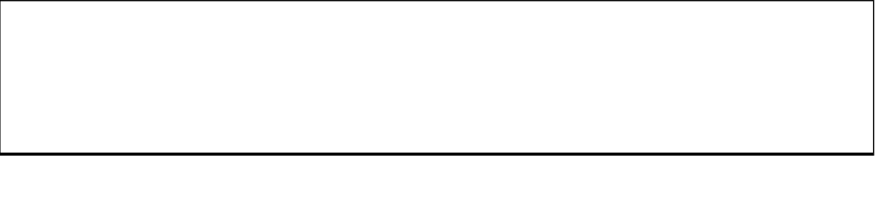

What are the activities that will be carried out in order to achieve these expected results?

Describe the participation of communities, groups or individuals in the project

Provide a timetable for the proposed activities and estimate the funds required

